|  |
| --- |
| PROJECT REPORT ON  GENERATING A PASSWORD USING PYTHON |
| BCE – P663 |



|  |  |
| --- | --- |
| **SUBMITTED BY:**  PUTTU SHANMUKHA SRINIVAS  196301073  B.TECH, CSE, VI SEM | **SUBMITTED TO:**  Mr.DEEPAK PAINULI  Assistant Professor  CSE Department, FET, GKV |
| DEPARTMENT OF COMPUTER SCIENCE & ENGINEERING FACULTY OF ENGINEERING AND TECHNOLOGY  GURUKUL KANGRI UNIVERSITY  2022-2023 | |

REPORT:

There are a few areas where the above code could be improved upon, but at a basic level, it meets many secure password generation requirements by today’s standards. As a newbie to Python or any other language, you should keep trying these types of programs as they help you explore more functions and in the long run will help you design your algorithms.

The longer a password, the more secure it is. A strong password should be at least 12 characters long. Random: Strong passwords use a combination of letters, numbers, cases, and symbols to form an unpredictable string of characters that doesn't resemble words or names.

An example of a strong password is “Cartoon-Duck-14-Coffee-Glvs”. It is long and contains uppercase and lowercase letters, numbers, and special characters. It is a unique password created by a random password generator. Strong passwords can be remembered but should not contain personal information.

MOTIVATION:

The main motivation behind working on this project was to provide user with the latest **Password generator which is a software tool that creates random or customized passwords for users. It helps users create stronger passwords that provide greater security for a given type of access.**

TOOLS AND TECHNIQUES:

* Basic PYTHON programming skills
* **Import string and random module**
* **random.choice method**
* JOIN method

## Python Program to Generate Password

To write a Python program to create a password, declare a string of numbers + uppercase + lowercase + special characters. Take a random sample of the string of a length given by the user:

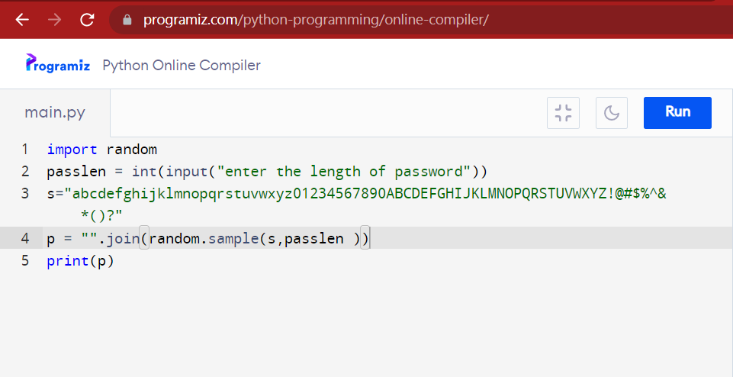

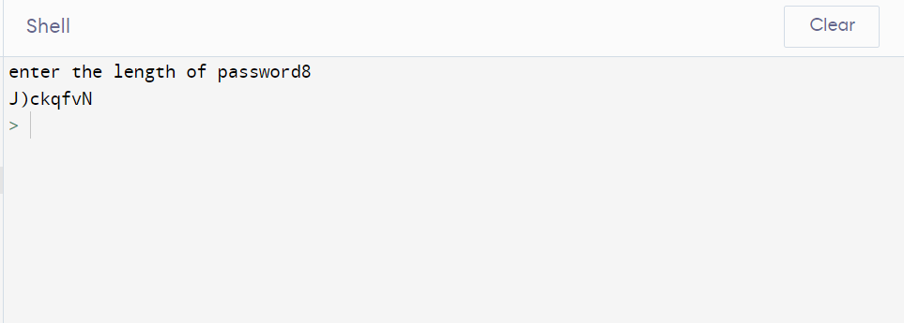

In the above code, I first imported the random module in Python, then I asked for user input for the length of the password. Then I stored the letters, numbers and special characters that I want to be considered while generating a password. Then I am doing a random sampling by joining the length of the password and the variable s, which will finally generate a random password.

### Summary

There are a few areas where the above code could be improved upon, but at a basic level, it meets many secure password generation requirements by today’s standards. As a newbie to Python or any other language, you should keep trying these types of programs as they help you explore more functions and in the long run will help you design your algorithms.